

IMPLEMENTING

CHAT BOT FOR EXAMINATION QUERY

Presented to the faculty of the Department of Computer Science

Lovely Professional University, Phagwara

**Submitted To :**

Mrs. Ankita Wadhawan

**Submitted by** :

|  |  |  |  |  |
| --- | --- | --- | --- | --- |
| S. No. | NAME | Reg. No. | Roll No. | Marks |
| 1. | **Manish Kumar** | 11805306 | 57 |  |
| 2. | **Mayank Singh** | 119161113 | 37 |  |
| 3. | **Harshit Bhura Jain** | 11805246 | 28 |  |
| 4. | **Abhishek Kumar** | 11805368 | 51 |  |

**Introduction**

The key to increase sales and customer loyalty is by improving your customer’s experience.

Customers are smarter today than they were five years ago and they expect you to be adept at your communications with them.

Gartner predicts that by 2020, a customer will manage 85 per cent of the relationship with a business without interacting with humans and hence, the increased demand and adoption of self-help service.

Chatbots are self-help tools for improving communications. Brands can use it to improve their customer’s experience, to generate more sales and build a deeper rapport with customers.

They allow your customers to easily interact with your brand through stimulated conversations.

***How chatbots can help you improve your business?***

* Chatbots Provide a Quick Response to Users
* Chatbots Create Engagement
* Businesses Use Chatbots to Handle Uncomplicated Tasks
* But They Can’t Completely Replace Humans
* Chatbots Allow Brands to Offer 24/7 Customer Service Support
* Unsatisfied Customers do not Return to the Brand
* Chatbots Reduce Human Error

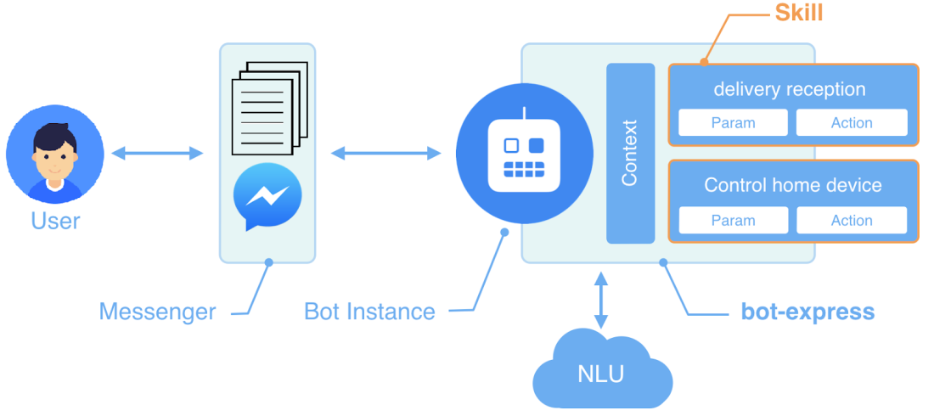

# PROPOSED METHODOLOGY

* **Using NLTK**
* **Using TensorFlow**
* **Using Reflection**
* **Using CHAT**
* **Using Basic Pairs**
* **Using Panda**
* **Using Matplotlib**
* **Using WordCloud**
* **Usning CounterFunction**
* **Using Numpy**
* **Using Tf-idf transformation and DataPipelines**
* **Using Selenium**

# Responsibilities of Team:

## Mayank Singh responsibilities:

## Most of the study related to the project was done by him.

## From the components used, to the Libraries used a description was needed which was the responsibility of this member. Consultation regarding the hardware components was done by this member.

## Manish Kumar responsibilities:

## A lot of work is done by this member in the coding section of the project. Also he did research based on the complications faced by the code on a regular basis.

## Harshit Bhura Jain responsibilities:

He helped in the github understanding and providing the necessary softwares used in the project.

## Abhishek Kumar responsibilities:

He helped in finding the research works along with Raj and also helped in keeping the idea out for an application which later failed but required a lot of efforts by him.

# RESULT AND DISCUSSION

Chatbot can be described as software that can chat with people using artificial intelligence.

These Software are Chatbot can be described as software that can chat with people using artificial intelligence. These Software are used to perform tasks such as quickly responding to users, informing them, helping to purchase products and providing better service to customers. to perform tasks such as quickly responding to users, informing them, helping to purchase products and providing better service to customers.